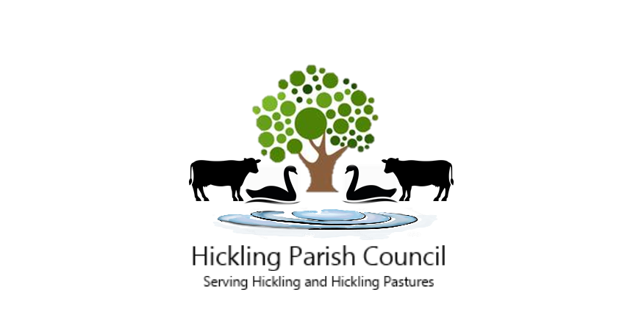

Clerk to the Parish Council: Cate Stokes
Donnyville, Main Street, Hickling, LE14 3AQ
Telephone: 07886169691
Email: hicklingparishclerk@gmail.com

PARISH COUNCIL MEETING
19th December 7.00pm

Hickling Parish Council will be holding a meeting on Tuesday 19th December 2023 in the Village Hall, commencing at 7.00pm. The agenda is outlined below, items received after the publication of this agenda may be considered at the meeting if an urgent decision is required.

- Election of Chair - to sign the declaration of office prior to opening of the meeting.

- Apologies

- Declarations of Interest

- Acceptance of minutes of meetings held on 14th November and 7th December 2023.

- Open session - to address matters raised by the public, limited to 15 minutes.

- Planning Applications

Ref. 23/02192/FUL
Applicant: Mr Paul Sharp
Development: Demolition of detached garage construct single storey rear Flat Roof extension and Associated Rear Patio Area. (Re-submission)
Location: 23 Harles Acres Hickling Nottinghamshire LE14 3AF

Consultation Deadline: 4th January 2024

- Decision Notices

Ref. 23/01540/LBC
Applicant: Mr Eric Parkes
Development: Remove existing windows & replace with double-glazed windows
Location: Church Farm, Main Street, Hickling, Nottinghamshire LE14 3AJ

Decision: Granted

Ref. 23/01651/FUL
Applicant: Mr Paul Frost
Development: Replacement of existing structures and units on site with 2 no. detached houses and 2 no. semi-detached houses alongside additional open green space. Change of use to residential dwellings (class C3). Detention pond.
Location: A E Faulks Ltd The Wharf Main Street Hickling Nottinghamshire LE14 3AH

Decision: Granted with conditions
Ref. 23/01813/FUL
Applicant: Mr David Taylor
Development: New agricultural building to be used as a cattle shed
Location: Turnpike Farm, Melton Road, Hickling Pastures, Nottinghamshire LE14 3QG

Decision: Granted

Ref. 23/01953/AGRIC
Applicant: Mr Robert Holt
Development: Agricultural storage barn.
Location: Agricultural Field To The West Of Main Street/Hickling Road, Hickling, Nottinghamshire.

Decision: Refused

- Portfolio Group Reports

Finance and Administration – Cllr Prosser

- Ringfenced monies: Request release of money (£250) to local history group to allow them to start funding the third sign – to be positioned at the Lengthman’s hut.

Environment – Cllrs Green and Playle

- Traffic calming/HGVs in Hickling

Highways and Street Furniture – Cllr Rowe

- A606 repairs/ resurfacing update
- Noticeboard update

Assets – Cllr Prosser

- Walker’s green monthly inspection

Community Engagement – Cllrs Green and Lamb

- Website update

- Ward Members Reports - Update from County Councillor Cottee and Borough Councillor Combellack.

- Finance
- Balance of accounts
Current account – £13831.55
Reserve Account - £3879.78

- Payments due

Cheque no. Payee Description Amount
BACS NALC New councillor training (inv 3040) £35.00
BACS NALC New Clerk training (inv 3041) £60.00
BACS C. Stokes Clerk’s Salary (1.12.23 – 31.12.23) Addendum
BACS C. Stokes Clerk’s Expenses (1.12.23 – 31.12.23) £26.00
BACS Village Hall Hall Hire Invoice £72.00
Date of next meeting: 9th January 2024.
To: Cllrs: Green, Lamb, Playle, Prosser, Conway and Rowe. Also, NC Cllr Cottee & Borough Cllr Combellack
Published: 12th December 2023

