**COUNCILLORS NEWSLETTER FOR THE RESIDENTS OF**

HICKLING, UPPER BROUGHTON, HICKLING PASTURES, COLSTON BASSETT, KINOULTON & LANGARCUMBARNSTONE

**A HAPPY AND HEALTHY NEW YEAR TO YOU ALL**

**From Cllr. Tina Combellack**

**SAVE THE SWIFTS**

A motion passed at Rushcliffe Full Council meeting made National Headlines.

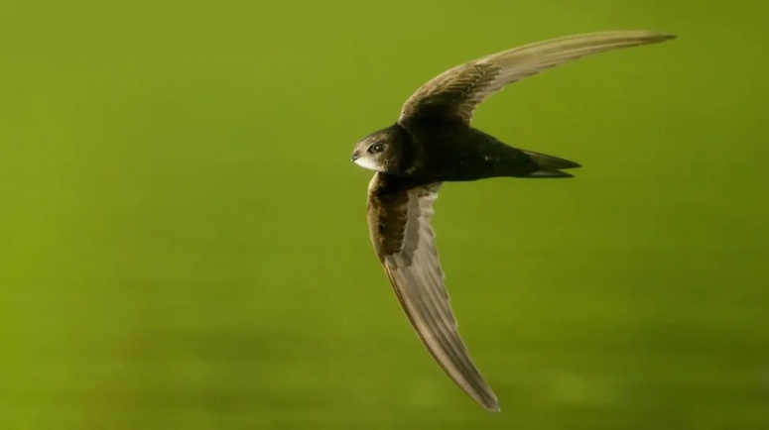

IMAGE SOURCE,RSPB

The motion to install the nesting bricks was passed unopposed at a meeting of the full council on Thursday

**By George Torr**

BBC News, East Midlands

**A council has pledged to make at least 50% of homes on new developments include "swift bricks".**

Rushcliffe Borough Council said installing the bricks, which have small holes in, would encourage the endangered bird to nest in new communities.

The bricks are designed to allow small birds to access a space to nest.

Deputy council leader Abby Brennan said the move "has the potential to halt the decline of swifts".

The decision will now be attached to all relevant planning permissions for new buildings granted in Rushcliffe under laws that support the environment.

Councillors also supported a requirement for new commercial and industrial developments to have a minimum of three swift bricks installed per unit.

The council is now reviewing where the bricks can be added to its own existing buildings.

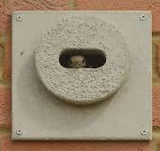

IMAGE SOURCE,RSPB

Here is an example of a swift brick - the RSPB say they can also help other wildlife, including red listed species like house sparrows, starlings and house martins

The RSPB said swifts liked to live in houses and churches, squeezing through tiny gaps to nest inside roofs but as more old buildings were renovated and gaps in soffits closed up, swift nest sites were fast disappearing.

Swifts were added to the red list, which is the highest conservation priority with species on this list needing urgent action, in 2021.

**Flooding**

I just wish to thank all those who helped in flooded areas – there was an enormous co-ordinated response to flooding. Councillors, Officers and outside agencies were working round the clock to ensure everyone’s safety.

A very prompt cleanup operation also went into action.

As a reminder training is available from the County Council for those who wish to be flood wardens. Having trained wardens in your community is an enormous help when these situations strike. Please contact your Parish Council and myself if you would be willing to become a Flood Warden.

**Financial help** will be available for those who were flooded.

1. Flooded households in eligible affected areas, who can apply for up to £500 cash to help with immediate costs.
2. Households and businesses significantly affected, who will be eligible for 100% Council Tax and business rates relief for at least three months.
3. Small-to-medium sized businesses in eligible affected areas, who can apply for up to £2,500 from the Business Recovery Grant to help them return quickly to business as usual.
4. Eligible flood-hit property owners, who can apply for up to £5,000 to help make their homes and businesses more resilient to future flooding via the Property Flood Resilience Repair Grant Scheme.
5. Farmers who have suffered uninsurable damage to their land will be able to apply for grants of up to £25,000 through the Farming Recovery Fund towards repair and reinstatement costs for farmers adversely affected by exceptional flooding.

[The Government's full announcement is available on its website.](https://gbr01.safelinks.protection.outlook.com/?url=https%3A%2F%2Fwww.gov.uk%2Fgovernment%2Fnews%2Fgovernment-payments-for-communities-affected-by-flooding&data=05%7C02%7Ccllr.TCombellack%40rushcliffe.gov.uk%7C0dd8c43a5052428c652808dc1070fbae%7C0fb26f95b29d4825a41a86c75ea1246a%7C0%7C0%7C638403324647764586%7CUnknown%7CTWFpbGZsb3d8eyJWIjoiMC4wLjAwMDAiLCJQIjoiV2luMzIiLCJBTiI6Ik1haWwiLCJXVCI6Mn0%3D%7C3000%7C%7C%7C&sdata=9sVR%2BowkmMO5UVjf2t3qyRsTdUkB0GovdOi5BYWUgmY%3D&reserved=0) <https://www.gov.uk/government/news/government-payments-for-communities-affected-by-flooding>

Riparian owners – those with hedges and ditches, walls drains and gullies on their properties fronting or affecting public areas, are responsible for keeping these clear and free of debris. Driving around I have been pleased to see some wonderful drainage ditch and street clearance. It all helps when heavy rains persist.

**COMMUNITY SUPPORT SCHEME**

Every year I receive £1000 in grant monies to be distributed for various community initiatives. We are coming to the end of the Council Financial year so would welcome any requests as soon as possible. I always like to allocate my fund as it can help many village causes.

The 22/23 fund went to

Colston Bassett Parish Council Memorial Plaque £226.50

Hickling Parish Council Jubilee Event Support £200.00

Langar Cum Barnstone Memorial Bench to 207 RAF squadron at Langar Airfield £150.00

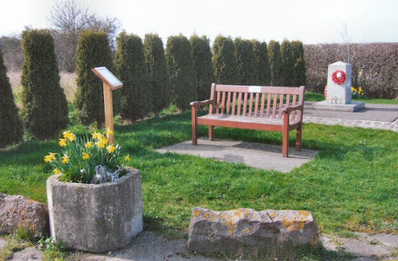

Upper Broughton History Group Laptop for archives £423.50 to help record details of historic documents found in a village outhouse. The documents when fully translated from the Old English and Latin appear to go back to the 16th century.

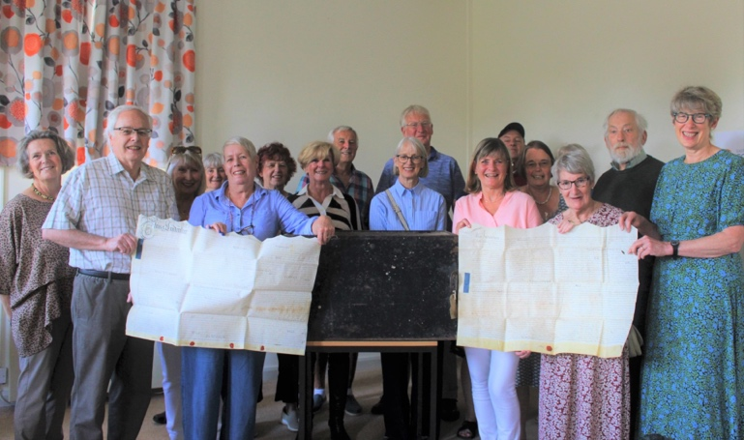

About the Community Support Scheme

The Council has a Community Support Scheme which enables each Councillor to put forward proposals for expenditure on small projects in their ward or community. Each Councillor currently has a budget of £1,000 each year to spend.

What this grant **can** be spent on:

* Improvements to community facilities within the ward
* Community events or activities within the ward that benefit all/a wide range of residents of the ward
* Investment in community infrastructure within the ward
* Support to a religious organisation where the project/event to be delivered benefits the wider ward (for example, repair of church clock)
* Support to a local school or academy where the project/event to be delivered benefits the wider ward
* Section of the community within the ward with a specific need.

What this grant **cannot** be spent on:

* Anything illegal
* Projects of a party-political nature, including supporting political organisations
* Supporting religious groups, activities or events, where the benefit is for that group only.
* Requests which directly benefit a sole individual
* Requests spent on consumables
* Support to lobbying or campaign groups
* The direct employment costs of staff or hospitality payments (including food and drink)
* Anything that will bring the Council into disrepute or damage the Council’s reputation.

A Community Support Scheme Application Form must be completed by the applicant and the councillor, and should include written evidence from the applicant outlining what the money is to be used for.  Completion of the online form is preferable although you can also download a pdf copy to print out. Printed forms should be returned to the Business Support Unit. The grant is usually paid by BACS transfer

**TOWN & PARISH FORUM**

RCAN are currently planning the spring forum which is taking place at **Rushcliffe Arena on Friday 22nd March 2024 from 9.30am – 12.30pm**, agenda to follow.

the theme is governance. **Kaffy Rice-Oxley, CEO of Notts ALC** (Association of Local Councils) will be providing an update on the following:

* Code of Conduct – importance of adopting LGA CoC as recommended by NALC & overview
* Civility and Respect Pledge – creating a positive environment so that conflicts don’t arise
* Policies – a list of the documents (templates available from Notts ALC) to set you up for success and prevent issues emerging
* Local Council Award Scheme – scheme to support the council’s ongoing development

**Gemma Dennis, the Borough Solicitor** will also be attending and will cover:

* Declarations of Interest – recognising the different categories of interest which need to be declared
* Standards complaints – explaining the process for considering a complaint, the options for resolving a complaint and potential sanctions

**This is an important meeting and I urge as many Councillors as possible to attend – it is not just the content of the meeting but the networking which is invaluable.**

This is proving to be a very busy and pressurised Council term – If you have any queries regarding Council, Community or planning issues please contact me at [Cllr.tcombellack@rushcliffe.gov.uk](mailto:Cllr.tcombellack@rushcliffe.gov.uk) and I will endeavour to respond as quickly as possible. If If I don’t know the answer I will find someone who does.